**BE2080 Week#6**

**1. Please submit the .m file or .mlapp file for each question. If you copy your program into a word file, we are unable to grade it.**

**2. Please check and make sure all your files are submitted.**

1) (10 points) Write a Matlab class named Point2D. It has two properties x and y. The constructor has two input arguments whose values will be assigned to the properties x and y. The class has a method Distance, which calculates the distance between the point (x, y) and the origin (0,0) and return it as the output argument. The distance is dist = .

2) (10 points) Write a GUI program using AppDesginer with 2 buttons, named as “RED” and “BLUE”. Click the RED button will change the window background to red, and click the BLUE button will change window background to blue.

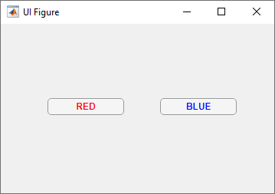 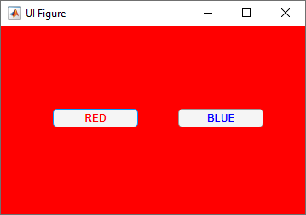 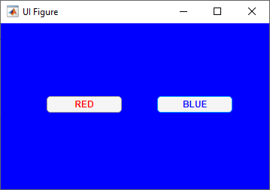

3) (10 points) Write a GUI program with **three Edit Fields**. As shown below, the first Edit Field “Input Numbers” is a ‘Text’ Edit Field, and the other two below are ‘Numeric’ Edit Fields. You can type in sequence of numbers in the “Input Numbers”. The numbers should be separated by either space or comma. Then hit the ENTER key, the “Counts” Edit Field should show the count of numbers you enter as an integer; the “Mean Value” Edit Field should show the average of the all numbers entered with exactly two decimals.

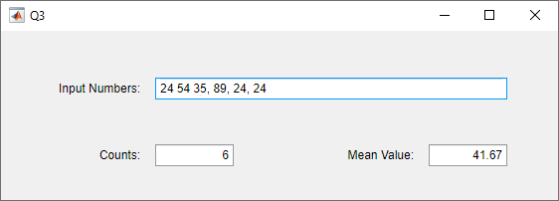

4) (10 points) Write simple calculator that can only do: addition +, subtraction -, multiplication *, and division /. A user can enter numbers in two numeric Edit Fields, choose a operation from a Drop Down, then click the Button “=” to show the result in a Label with two decimal points.

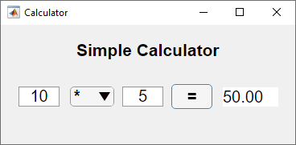 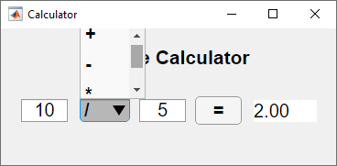

5) (10 points) Write a GUI program as shown below. The user will click the “Open’ button to open the world population data (population.txt). Show the file path in the label next to the ‘open’ button, and plot the data in the axes as shown. Use log scale for the y-axis. In addition, the radio button group allows the user to change the curve color. At beginning, the curve should be plotted in red.

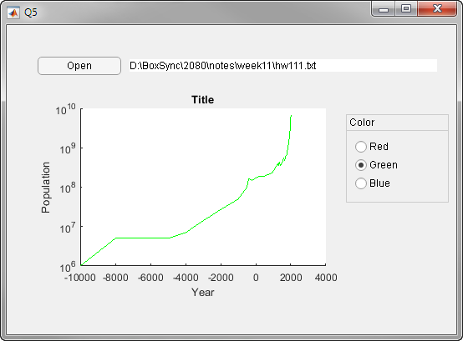

6) (10 points) Write a GUI program to check basic file information. The program has **1 button**, **1 ‘numeric’ Edit Field**, and **3 Labels** as shown below. The ‘numeric’ Edit Field is named as “Number of Files Checked”.

Click the button “Choose A File” will open a file browser, pick up a file and click OPEN. The program will display in the 3 Labels:

(a) the folder name of the file to the Label next to “Folder:”;

(b) the name of the file to the Label next to “Name:”;

(c) the creation date next to “Date Created:”.

In addition, the program keeps track of number of files it has checked and display the number in the numeric Edit Field. The above file information can be obtained using the Matlab function ‘dir’, which returns a struct variable containing six fields. Check the Matlab document and understand how to use ‘dir’ to get this information.

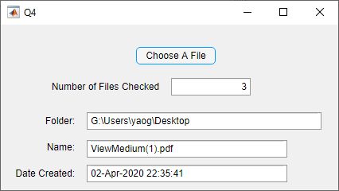

7) (20 points) Adapt the Body Mass Index (BMI) calculation program you developed previously into a Matlab GUI based program. An example of the GUI image is shown below.The Body Mass Index (BMI) is calculated as:

$$BMI=\frac{WEIGHT in pounds}{{\left(HEIGHT in inches\right)}^{2}}*703$$

The weight status is categorized as:

**Underweight:** BMI<=18.5

**Normal:** 18.5<BMI≤24.9

**Overweight:** 24.9<BMI≤29.9

**Obese:** BMI>29.9

The user can enter the height and weight using either the **numeric Edit Fields** or two **sliders**. If a slider is used to adjust the data, the corresponding numbers should be displayed in the corresponding Edit Fields, and vice versa. The user will click the Button “Check BMI” to show the BMI.

The height slider has units in inches. For a height number of INCH, it can be converted to [floor(INCH/12)] ft and [INCH – 12*floor(INCH/12)] in. For example, 70 in = 5 ft 10 in. Similarly, a number in FEET and INCH can be converted to inches as: [FEET*12+INCH] in.

As illustrated in the example shown at right, please **use colors to illustrate BMI category:**

Green 🡪 normal

Yellow🡪underweight or overweight

Red🡪obese

